CURRICULUM VITAE
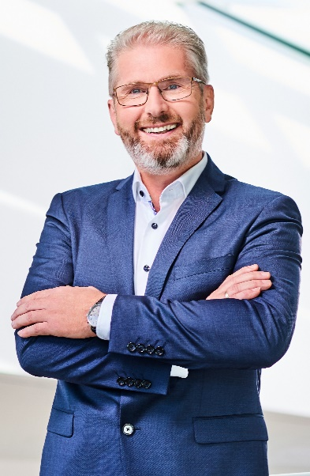 | JOSEF  HAINZL  CONTACT  Industriezeile 56  4021 Linz AUSTRIA  0043 732 7892 492  j.hainzl@aquasys.at  j.hainzl@hainzl.at
 | WORK EXPERIENCE
2020 – till now | Managing Director at AQUASYS Technik GmbH  AQUASYS Technik GmbH is a 100% member of Hainzl group located in Linz Austria
2014 – 2019 | Executive Manager at AQUASYS Technik GmbH
2009 – 2013 | Executive Manager at HAINZL Industriesysteme
2003 – 2008 | Sales Group Manager at HAINZL Industriesysteme
1996 – 2002 | Sales Engineer at HAINZL Industriesysteme  for water hydraulic systems
1992 – 1996 | Skilled Worker at HAINZL Industriesysteme
1988 – 1992 | Apprenticeship at HAINZL Industriesysteme
 | EDUCATION
Since 1997 | Several sales and management trainings
1993-1997 | Technical High School: Industrial Engineering and Management
1992-1993 | Military Services Austrian Army
1988-1992 | Apprenticeship technician
1983-1988 | Primary School
1979-1983 | Elementary School
Linz, 2024-02-04 | 